Slot-1 report

Oasis crew team 11

**Data Science Problem Statement:**

Predict if the client will subscribe to a term deposit based on the analysis of the marketing campaigns the bank performed.

**Preprocessing Techniques applied:**

**a) Missing Value Treatmesnt:**

🡪No null values found in numerical columns and object columns

🡪"Unknown" values are identified as missing value for categorical columns

🡪 Mode is used to fill “unknown” of each categorical column

**b) Label Encoding:**

🡪Label encoding on all the categorical features and the target is performed.

**c) Imbalanced Data Handling:**

**🡪** The class distribution in the target indicates the problem imbalanced.

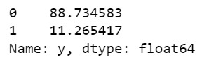

**Exploratory Data Analysis:**

**Count plots:**

Shows the trends of some categorical columns.

* -Job - Admin, Blue-collared and Technician are most likely to subscribe to a term deposit.

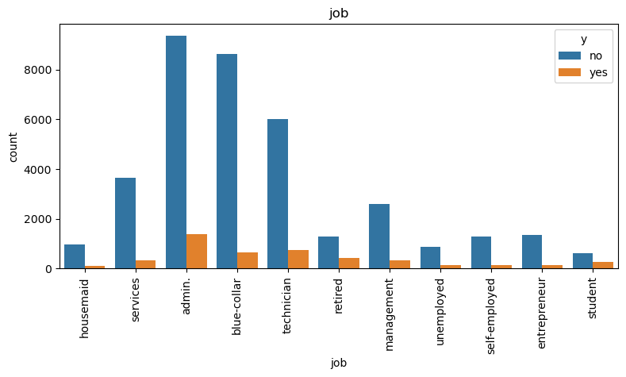

* -Education - People from education sector(university and high school)are most likely to subscribe to a term deposit.

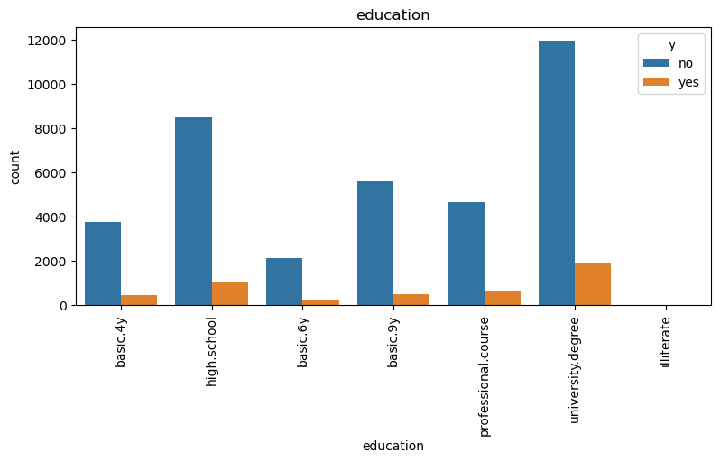

* -Loan - People with no personal loan are most likely to subscribe to a term deposit.

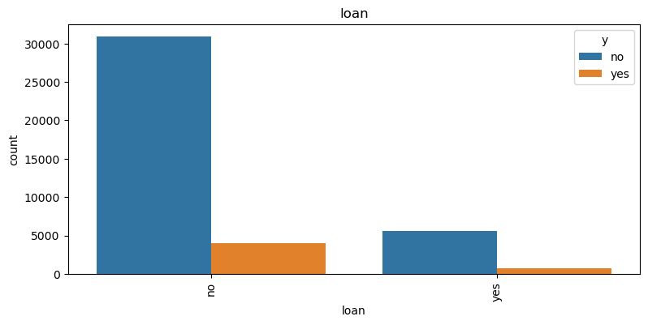

* -Contact - People with cellular contact are most likely to subscribe to a term deposit.

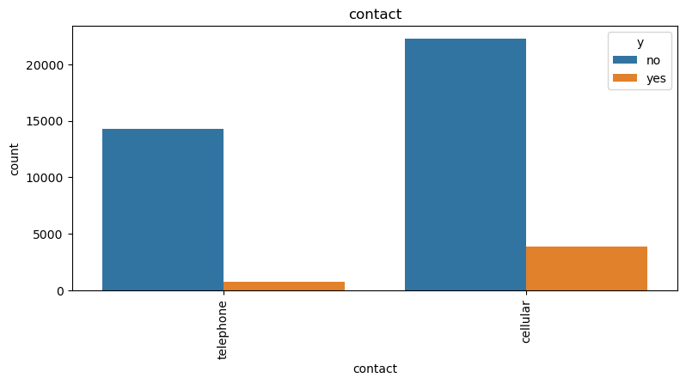

* -Month - May, June, July and August are the best times to get customers to suscribe.

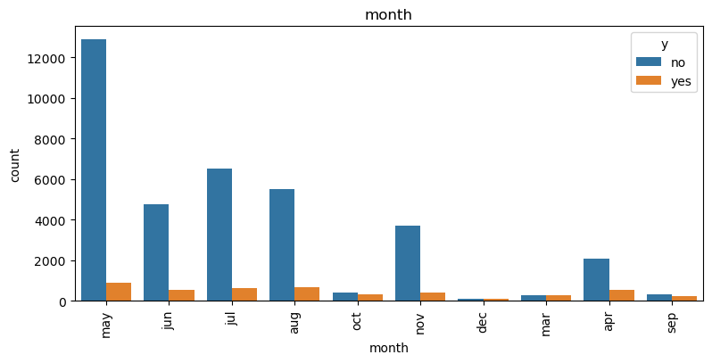

**Histograms**

Understanding Age Distribution:. This information is valuable to get marketing strategies to different age groups.

Campaign Contact Frequency: Creating histograms for "campaign" can help assess how frequently clients were contacted during the campaign.

Previous Campaign Contact: Histograms for "previous" can reveal the distribution of the number of contacts made with clients before the current campaign.

Economic Indicators: Histograms for economic indicators like "euribor3m" and "emp.var.rate" can provide insights into the distribution of these indicators, which may impact client decisions regarding term deposits.

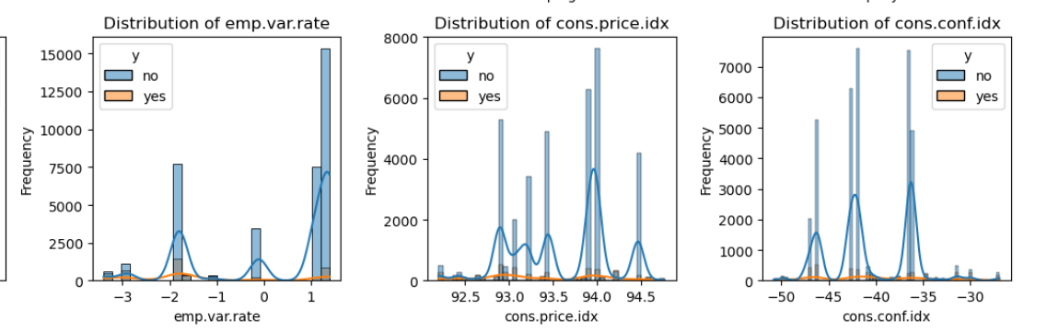

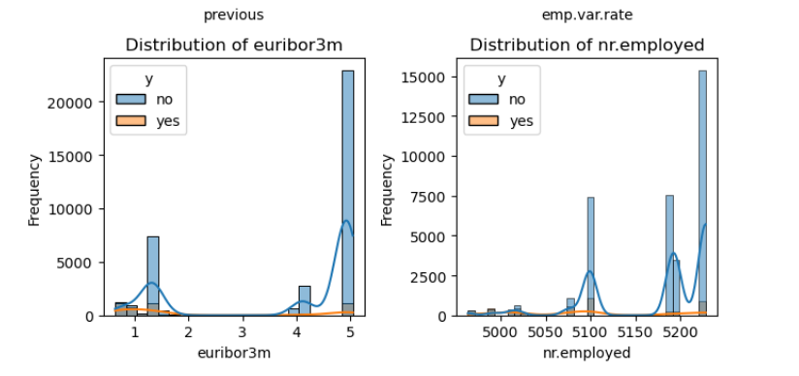

**Box Plots :**

* From this we can indetify the outliers and thus remove it to improve the accurate results
* From this we can see that duration has many outliers and should be removed.

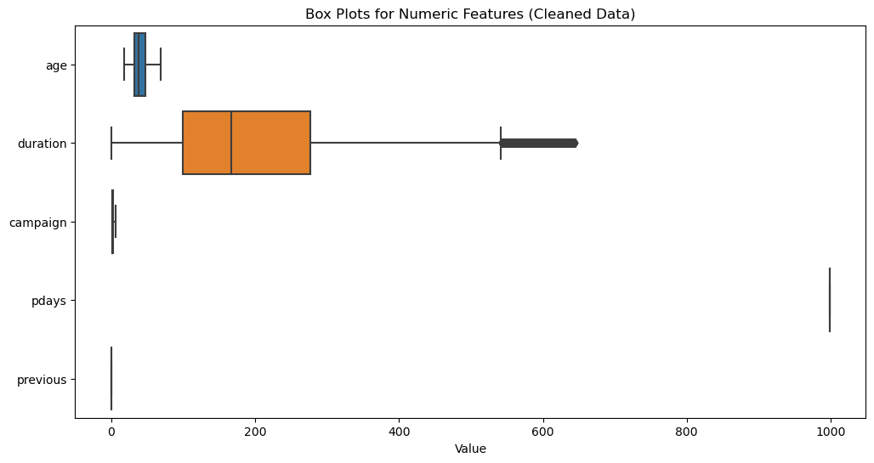

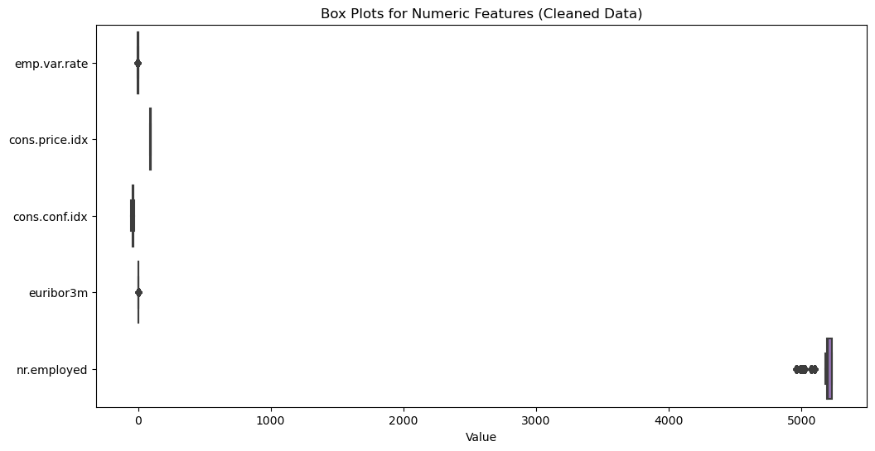

**Correlation-Matrix**

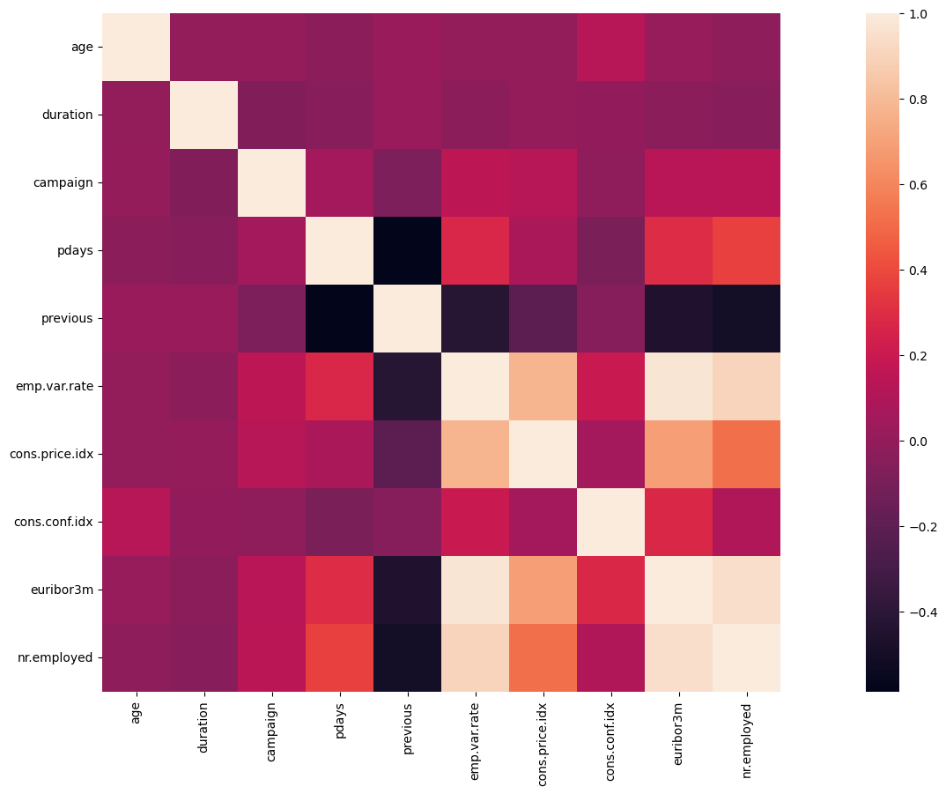

Heat Map Method to determine correlation between the continuous variables.

There was a strong positive relationship between emp.var.rateand euribor3m with correlation 97%.

The emp.var.rate attribute also had a strong positive correlation with nr.employed at 0.91 and with cons.price.idx at 0.78

**Scatter Plots**

By using scatter plots we can analyse the trends

